PRACTICE 04

Creating Alias
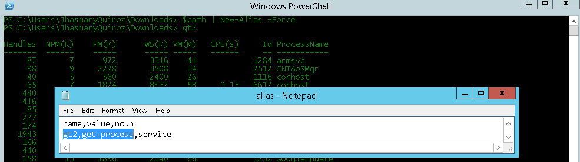

Path
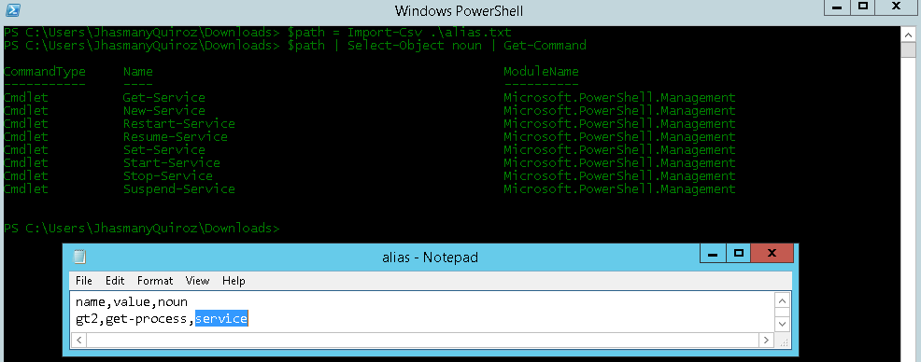

Commom Parameters –verbose

Without verbose

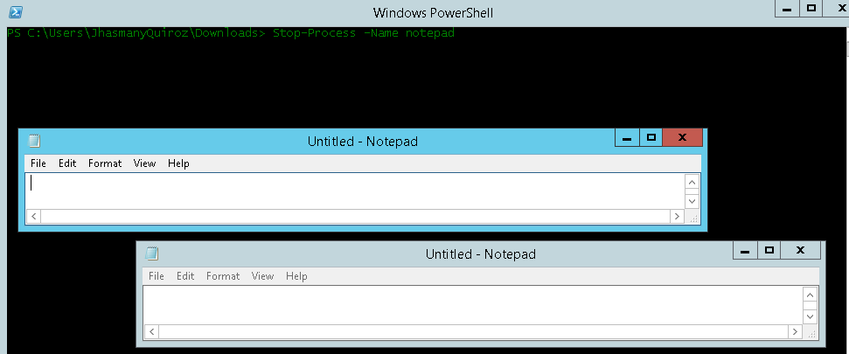

With verbose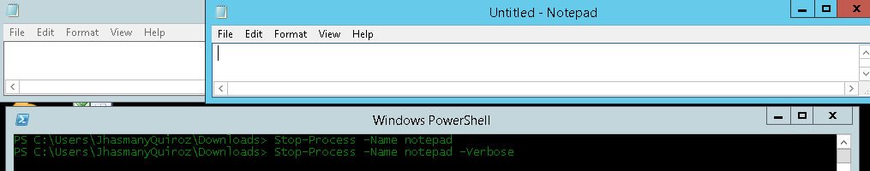

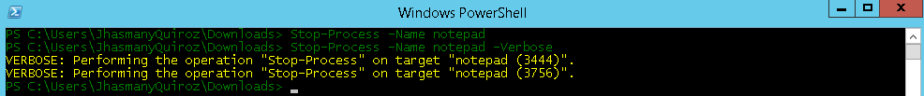

REFERENCIAS:
http://respag.net/par%C3%A1metros-objetos-y-formato-en-ps.aspx
https://sites.google.com/site/aimbsor/powershell-1/09-powershell
http://www.mauriciomatamala.net/SO/powershell.php
http://maxplanck2014.blogspot.com/2014/07/aprender-los-nombres-de-comandos-y.html

